Practical No.1

**Title:-Processes communication-write a program to give solution to the producer-consumer problem using shared memory**

Input:-

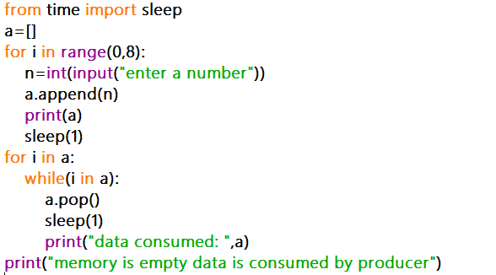

output:-

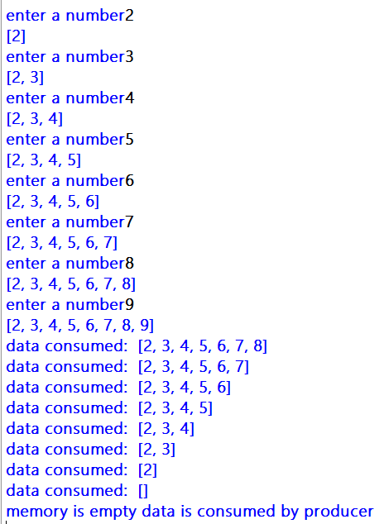

Write a program to give solution to the producer-consumer problem by using message passing:-

Input:-

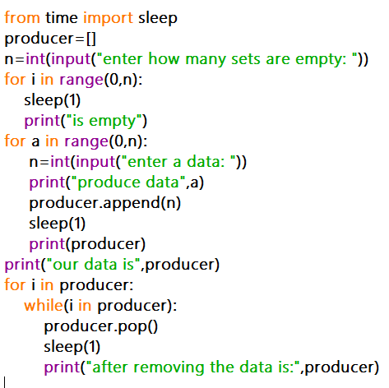

Output:-

